## **nintendo_soc_profile_fireemblem_grey.png**

## **Y’all know what time it is! It's Nintendo Society News Time!**

Remember guys, if you want to be receiving these emails each week then make sure to go to the Warwick SU website and you can pay for membership there! I’ll stop sending these emails to those who haven’t joined from next week!

**(Some special events will be happening from next week... so join! :o )**

And with that, here are this week's announcements:

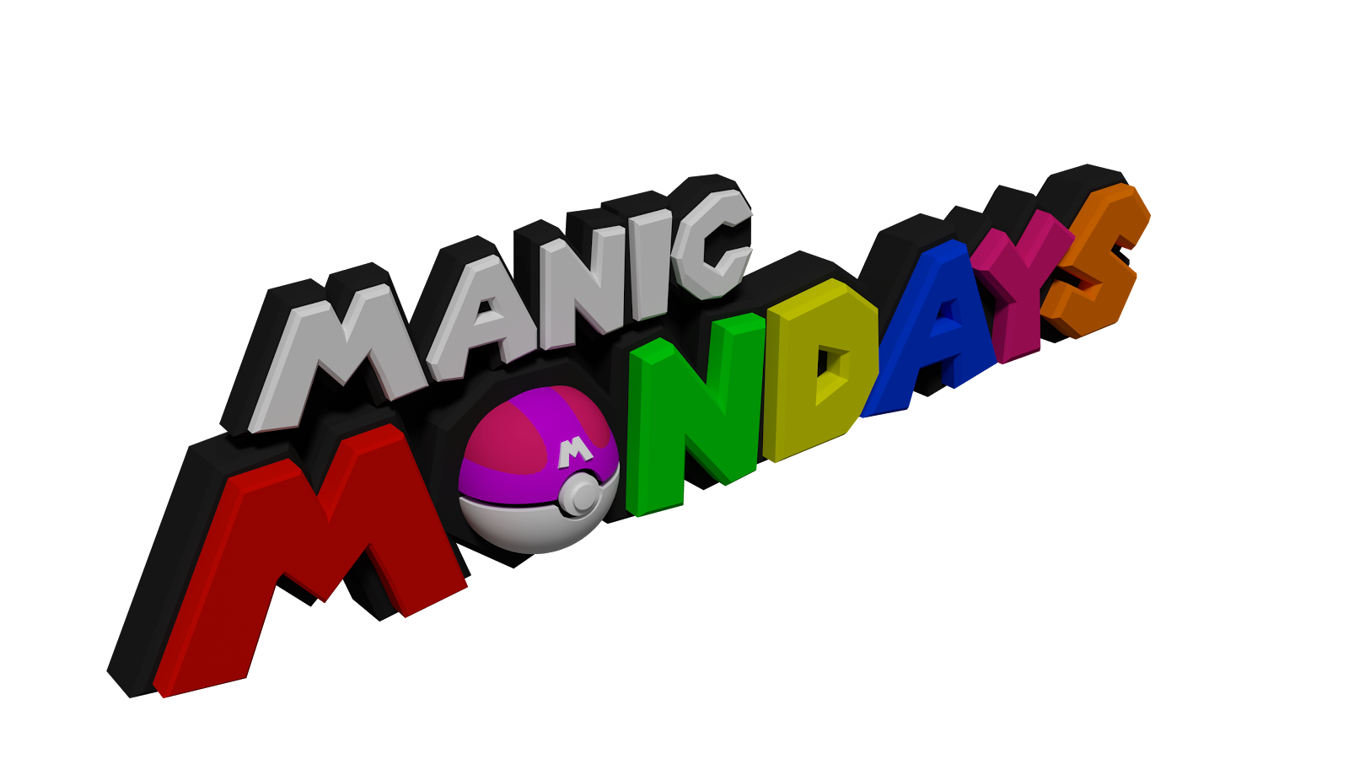

### **Monday 23/10, R1.13 & R1.15 (Ramphal Building), 5pm setup, 6-10pm**

Manic Mondays are all about enjoying Nintendo games! We will have 3DS’s, Wii U’s and Switch’s around for all of you to have a play on some of Nintendo’s finest games!



### **Wednesday 25/10, R0.03/4 (Ramphal Building), 2pm setup, 3-10pm**

This is our weekly Smash Bros. event! Wednesdays are dedicated gaming sessions for Super Smash Bros. for Wii U and Melee! Open to all skill levels from complete casual to more competitive level, and we will have multiple setups of each!

If you don’t know where the Ramphal Building is on campus then use the following link! We will have a banner outside the room to indicate where we are! <https://campus.warwick.ac.uk/?cmsid=18&project_id=1>

---------------------------------------------------------------------------------------

And that’s all the time we’ve got! Until next time…

Don’t get cooked… Stay off the hook! :D

Timothy Sit

Nintendo Society President



---------------------------------------------------------------------------------------

### **Find us on Social Media:**

Join our Facebook group:<https://www.facebook.com/groups/warwicknintendo/>

Follow our Twitter:<https://twitter.com/warwicknintendo>

Join our Discord Chat:<https://discordapp.com/invite/Rf6QyfG>

Subscribe to our YouTube:<https://www.youtube.com/channel/UCzO_bZNfQDCAQa_zkEUgGVg>